Hashing quizReport Issue

Multiple Choice Question
Which of the following can be stored as a key in a hash map?
Array/list
Integer
Mutable string
Immutable string
Boolean
Float
RedoSubmit
Correct.
Hash map keys must be immutable.

Multiple Choice Question
Which of the following can be stored as a value in a hash map?
Array/list
Integer
Mutable string
Immutable string
Boolean
Float
RedoSubmit
Correct.
Unlike keys, hash map values do not need to be immutable.

Multiple Choice Question
Which of the following would not be O(1) with a hash map?
Check if a key exists
Check if a value exists
Check how many keys there are
Delete a key from the hash map
RedoSubmit
Correct.
Only the keys are hashed.

Multiple Choice Question
For small inputs, using an array can be faster than a hash map. Why?
Trick question - hash map is O(1) and arrays are O(n), hash maps are faster
Because a hash map isn't O(1) in the average case for small inputs
There is overhead associated with a hash map such as the hash function
Because if the array is small then its operations are also O(1)
RedoSubmit
Correct.
Time complexity doesn't always mean everything.

Carefully read and make sure you understand the problem 2352. Equal Row and Column Pairs. Then, consider the following solution:

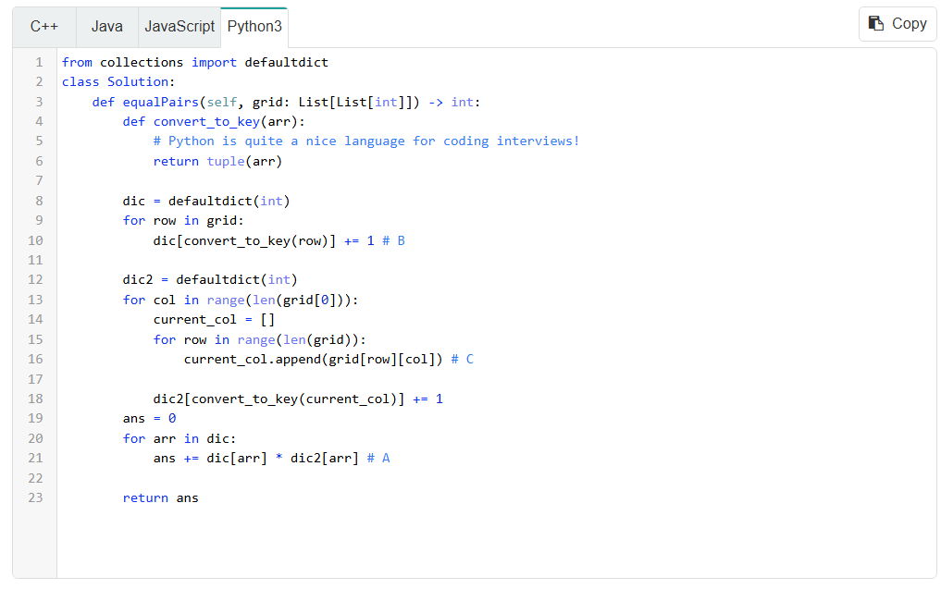

The following is a list of questions for you to answer. Click on each question to reveal the answer.
Why are we using a convertToKey function? Why don't we just use currentCol as a key?
Mutable data types like lists are not hashable. To represent currentCol as a key in a hash map, we must convert it to an immutable form like a string or tuple.

Consider the line of code with the comment "A". We are iterating over the keys of dic1, but also checking dic2. Depending on the language, we may or may not need to write slightly different code to obtain the value in dic2. Why, and how do we make sure the calculations are correct?
C++: std::unordered_map conveniently sets a default value of 0 for keys that have not been set. Anything multiplied by 0 is 0, which is what we want since if the key is not present in dic2, no pairs can be formed.
Java: If we simply used get and the key did not exist in dic2, we would have an error. We use getOrDefault, which will give us a default value if the key does not exist. We use a default value of 0 - anything multiplied by 0 is 0, which is what we want since if the key is not present in dic2, no pairs can be formed.
JavaScript: If key does not exist in dic2, then dic2.get(key) will return undefined. By using the || operator, if the first argument dic2.get(key) is undefined, it will give us the second argument 0. Anything multiplied by 0 is 0, which is what we want since if the key is not present in dic2, no pairs can be formed.
Python: collections.defaultdict(int) functions similarly to C++ std::unordered_map. See the C++ explanation.

Consider the line of code with the comment "B". What would happen to the algorithm if we deleted it?
The hash map that tracks the rows would not have any keys populated. Thus, when we iterate over the columns, we will not find any matches and the answer will be stuck at 0.

Consider the line of code with the comment "C". What would happen to the algorithm if we deleted it?
Instead of building the current column, we would be stuck with an empty array. Thus, we will not find any matching rows and the answer will be stuck at 0.

